**TUTORIAL REVIEW PROPOSAL**

**CHEMICAL SOCIETY REVIEWS**

**PROPOSED TITLE: Photo-click reactions for biological applications (changed)**

**AUTHOR(S):** Prof. Jianfeng Cai **Yan Zhang1**

**ADDRESS:** University of South Florida,  **1School of chemistry and chemical engineering, Nanjing University, Nanjing, China, 210023**

**EMAIL:** Prof. Jianfeng Cai’ email address, **njuzy@nju.edu.cn**

**PROPOSED SUBMISSION DATE: Oct 2019**

**PROPOSAL QUESTIONS:**

Please complete all sections, ensuring your answers are succinct and within the word limit.

**1) Please comment on the current importance of the field**

Photo-click reactions with fast ligation rate and good biocompatibility are highly demanded in the exploration of biological systems due to the temporal and spatial resolution realized through photo-irradiation. The development of photo-click reactions initiated by UV or visible light has attracted attention from both organic chemists and chemical biologists. Several new photoreactions induced by mild UV or visible light have been successfully applied to biological systems. This cutting-edge field greatly encourages researchers from different fields including organic chemistry, chemical biology and life sciences to work together and construct photo-active molecular tools to solve important biological questions.

**2) What are the implications for the wider scientific community?**

Optogenetics based on the ligation and dissociation of photo-sensitive proteins has been chosen as the "Method of the Year" across all fields of science and engineering by the interdisciplinary research journal [*Nature Methods*](https://en.wikipedia.org/wiki/Nature_Methods) in 2011. Limited type and number of photo-sensitive proteins and the difficulty to integrate these proteins with specific functional proteins then became important issues to be addressed to develop versatile tools in optogenetics. Biocompatible photo-click reactions, featured as photo-induced fast ligation under bio-compatible conditions, hold the promise to develop easy-to-handle chemical tools with similar function of photo-sensitive proteins. Meanwhile, how to push various photo-induced organic reactions to become bio-compatible reactions with unique bio-applications is a question of broad interests for organic chemists. The development of photo-click reaction is thus important from the point of view of both chemists and biologists. **Pharagraph should be shrunken to 100 words.**

**3) To which communities will your article appeal?**

The review would be of interest to the following communities:

1. Chemists focusing on photo-chemistry including visible-light catalysed reactions
2. Chemical biologists to develop new methods to explore biological systems
3. Biologists seeking new chemical tools with temporal and spatial resolution to solve biological problems
4. Researchers with interested in photo-responsive biomaterials

**4) Please comment on any other reviews published on a similar topic, justifying why there is room for another review**

In 2011 and 2014, two reviews were published on the chemistry and biological applications of the UV-induced tetrazole-ene photo-click reaction which was considered as a promising bioorthogonal reaction in chemical biology (*Acc. Chem. Soc.*, **2011**, *44*, 828; *Curr. Opin. Chem. Biol.*, **2014**, *21*, 89). After that, no review paper on similar topic has been published. In the past several years, tremendous efforts have been made to explore the biological applications of the photo-click reaction as well as to develop new photo-induced bioorthogonal reactions. A summarization on these efforts will definitely help the readers understand the scope and future direction of this multi-disciplinary research field. Therefore we propose to write a tutorial review on recent development of photo-click reactions with respect to new chemistry and novel biological applications, with emphasis on related work published in the past 5 years in this field.

**5) Please list the key learning points (up to five) that your review will offer**

1. The significance and common strategy to develop biocompatible photo-click reactions for multi-disciplinary research
2. The requirements on photo-induced ligation reactions with the potential to be developed into photo-click reactions useful in biological systems
3. The unique feature of photochemical tools to explore biological systems
4. Construct biomaterial scaffolds with highly spatiotemporal control
5. The potential applications of photo-click reactions in biology system

**6) *Chem Soc Rev* aims to publish only the very best review articles while avoiding repetition, and one way to achieve this is to have groups of authors to collaborate on writing the definitive review on a particular area. Are you willing to work together with other author group/s on the proposed review? If so, please identify some potential researchers with whom it might be suitable for you to collaborate. If not, please explain briefly why the proposed review would not benefit from being a collaborative effort.**

Prof. Jianfeng Cai at the University of South Florida

You need to describe about him as detail as possible, e.g. his strong points etc

Cai’s research is focused on the expansion of interdisciplinary research at the interface of chemistry and biology to design and synthesize novel peptidomimetics and small molecules that modulate protein-protein interactions involved in critical cellular processes. Understanding how these compounds interact with proteins will help to reveal mechanisms governing cell activities. Specifically, He has developed a new class of sequence-specific peptidomimetics-AApeptides, inspired by chiral PNA backbones. His research findings reveal that AApeptides could fold into well-defined protein-like secondary and tertiary structures, and they display remarkable biological potential for the recognition of protein and nucleic acids. He has published more than 110 papers including *Acc. Chem. Res., PNAS, Nat Commun. JACS, Angew. Chem. Int. Ed, J. Med. Chem*, etc.

**7) Please provide section headings along with a brief discussion of each section and associated key references. List at least 10 of the main research articles you will use as core references in your proposed review.**

**Yan: You’d better make a short description as well as put a representative figure herein in each item**

1. Brief introduction on photo-induced bio-compatible reactions

2. Tetrazole-alkene photo-click reaction and its biological applications

2.1 Reaction mechanism and reactivity

Lin and co-workers first reported the rapid tetrazole-alkene photo-initiated cycloaddition in physical system which could be used as a compatible reaction for biological study. A two-step mechanism was proposed in which UV light or two-proton induced to generate nitrile imine intermediate that followed by 1,3-dipolar clycloaddition with the alkene dipolarophiles. Though the photogenerated nitrile imine dipoles also exhibit electrophilic character, which could undergo nucleophilic thiol and water additions, efforts were made to suppress the competing nucleophilic additions by tuning up the cycloaddition reactivity. In addition, a series of strained ring cyclopropanes were designed, which shows robust rate enhancement.

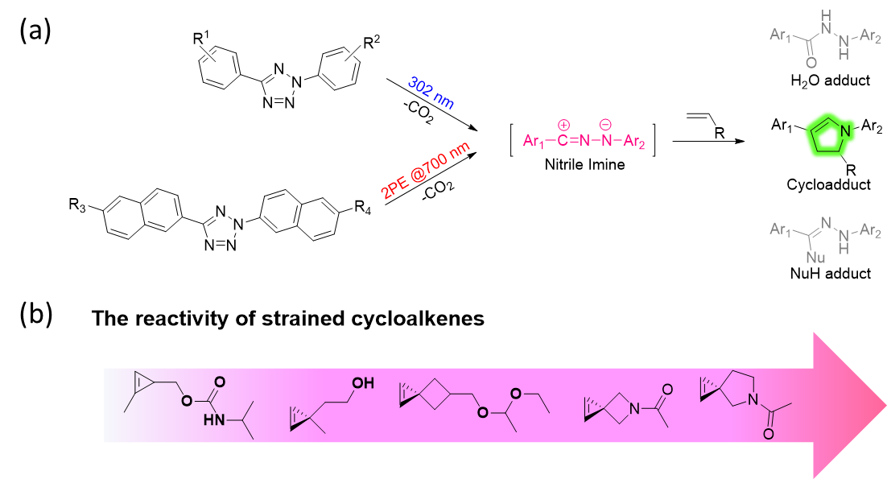

Scheme: Illustration the mechanism of photo-click cycloaddition and relatively reactivity of strained cycloalkenes.

2.2 Rapid site-specific protein photo-cross-linking and labeling

Genetic encode is a powerful chemical strategy for specific protein mutation, which is suitable for both alkenes and tetrazoles, as a result, subsequent photo-click reaction offers a temporal-special tools for site-specific protein labeling and protein-cross-linking.

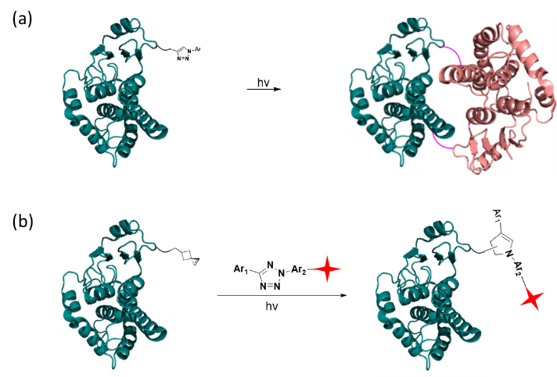

Scheme: Application of photo-click reaction for protein labeling and protein photo-cross-linking.

2.3 MicroRNA imaging and intracellular target identification

2.4 Construction of imaging probes

3. Photo-activatable click reactions and their biological applications

3.1 UV activatable strain-promoted azide-alkyne cycloaddition

Angle-strained cycloalkynes play are an important scaffold for click chemistry, which enable fast and efficient Cu-free click chemistry due to the highly ring strain. Popik and co-workers take advantage of the photochemical decarbonylation of cyclopropenones, the latter undergo rapid SPAAC to azide-tagged substrates, which enable the SPAAC triggered by single or nonresonant two- and three-photon excitation that reducing background labeling and nonspecific modification to achieve more precise control.



Scheme: Light triggered strain promoted azide−alkyne cycloaddition (SPAAC).

3.2 Light-activated Staudinger-Bertozzi ligation

In 2006, Carrico and co-workers developed photoactivable Staudinger-Bertozzi ligation by using photocaged phosphines strategy that are not susceptible to oxidation and efficiently inactivated prior to removal of the photoprotecting group, as a result, it enables spatial labeling of metabolically introduced azides in mammalian cells and on fixed zebrafish larvae.

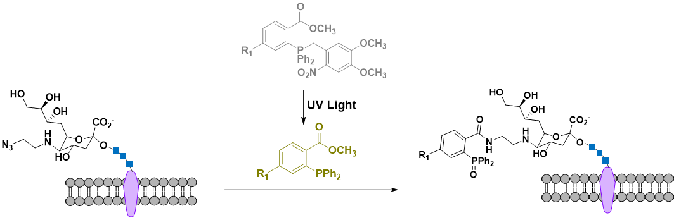

Scheme: Labeling of metabolically introduced azides by light-activated highly specific Staudinger−Bertozzi ligation

3.3 Photocatalytic tetrazine ligation

Tetrazine ligation, which referred the inverse-electron demand Diels−Alder reaction of s-tetrazines with alkene or alkyne dienophiles has emerged as an important reaction in the bioorthogonal toolbox. Fox and co-workers reported the first example of visible light induced tetrazine ligation which take advantage of the rapid oxidation of a dihydrotetrazine to a tetrazine by visible light and methylene blue that achieved using external stimuli to induce bioorthogonal activity. Turning on the tetrazine ligation by photocatalytic provide a new tool for a more flexible and powerful strategy in biological study.



Scheme: Visible light photocatalytic activation of tetrazine ligation

4. New generations of photo-click bioorthogonal reactions

4.1 Visible light-initiated bioorthogonal cycloaddition

Our group reported a visible light-trigged [4+2] cycloaddition with high reactivity under biocompatible conditions, which possess a distinct pathway from reported biorthogonal reactions that could be used for orthogonal protein labeling together with azide-alkyne click reaction or tetrazole-alkene reaction. The reaction was successfully applied to live cell surface labelling study with high temporal and spatial control.

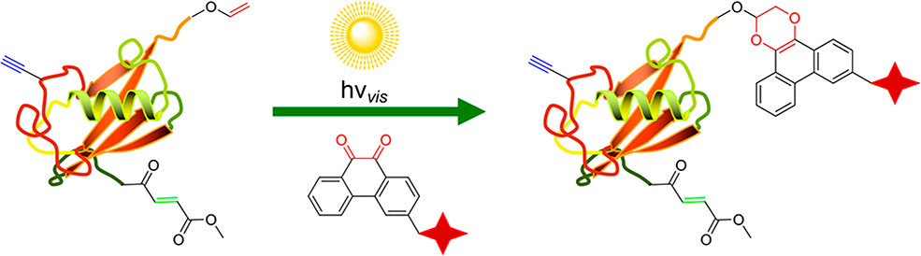

Scheme: Orthogonal labeling of protein by PQ-VE photo-click cycloaddition.

4.2 Diarylsydnones-alkenes/alkynes photo-click reaction

In 2018, Yu and co-works introduced a new type of high efficiency photo-click reaction, the DASyd-alkene photoligation, which has the same reactive dipolar intermediate with tetrazole under photo irradiation. In addition, ring-strained alkene, trans-cyclooct-4-en-1-ol (TCO) shows excellent reactivity as well as highly ratio of fluorescence turn-on effect, that has been applied for fluorogenic protein labeling selectively. They also investigated the diarylsydnones and ring-strained alkynes ligations under photo irradiation, which is ultra-fast and suppressed the background DASAC-reaction pathway, showing as a promising photo-click tools for detecting biomolecules in living cells.

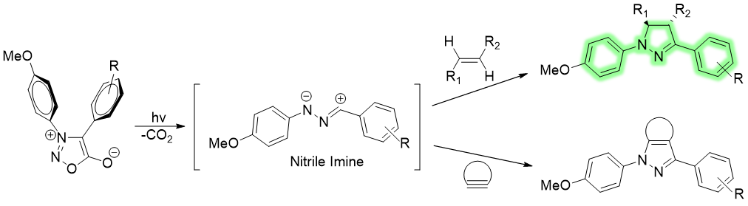

Scheme: Photo-active 1,3-dipolar cycloaddition of Diarylsydnones(DASyds) with various alkenes and alkynes

5. Perspective on developing new photo-click reactions and biological applications

**Associated key references:**

1. C. P. Ramil and Q. Lin, *Current Opinion in Chemical Biology*, 2014, **21**, 89-95.

2. G. Delaittre, A. S. Goldmann, J. O. Mueller and C. Barner-Kowollik, *Angewandte Chemie International Edition*, 2015, **54**, 11388-11403.

3. J. Hatano, K. Okuro and T. Aida, *Angewandte Chemie International Edition*, 2016, **55**, 193-198.

4. P. An, T. M. Lewandowski, T. G. Erbay, P. Liu and Q. Lin, *Journal of the American Chemical Society*, 2018, **140**, 4860-4868.

5. J. Li, L. Huang, X. Xiao, Y. Chen, X. Wang, Z. Zhou, C. Zhang and Y. Zhang, *Journal of the American Chemical Society*, 2016, **138**, 15943-15949.

6. L. Huang, Y. Chen, L. Chen, X. Xiao, X. Wang, J. Li and Y. Zhang, *Chemical Communications*, 2017, **53**, 6452-6455.

7. L. Sun, J. Ding, W. Xing, Y. Gai, J. Sheng and D. Zeng, *Bioconjugate Chemistry*, 2016, **27**, 1200-1204.

8. M. Zhou, J. Hu, M. Zheng, Q. Song, J. Li and Y. Zhang, *Chemical Communications*, 2016, **52**, 2342-2345.

9. C. D. McNitt, H. Cheng, S. Ullrich, V. V. Popik and M. Bjerknes, *Journal of the American Chemical Society*, 2017, **139**, 14029-14032.

10. M. Martínek, L. Filipová, J. Galeta, L. Ludvíková and P. Klán, *Organic Letters*, 2016, **18**, 4892-4895.

11. L. Shah, S. T. Laughlin and I. S. Carrico, *Journal of the American Chemical Society*, 2016, **138**, 5186-5189.

12. H. Zhang, W. S. Trout, S. Liu, G. A. Andrade, D. A. Hudson, S. L. Scinto, K. T. Dicker, Y. Li, N. Lazouski, J. Rosenthal, C. Thorpe, X. Jia and J. M. Fox, *Journal of the American Chemical Society*, 2016, **138**, 5978-5983.

13. J. Li, H. Kong, L. Huang, B. Cheng, K. Qin, M. Zheng, Z. Yan and Y. Zhang, *Journal of the American Chemical Society*, 2018, **140**, 14542-14546.

14. L. Zhang, X. Zhang, Z. Yao, S. Jiang, J. Deng, B. Li and Z. Yu, *Journal of the American Chemical Society*, 2018, **140**, 7390-7394.

**AUTHOR CV**

**Personal Data**

Name: Yan Zhang

Current position: Professor, School of Chemistry & Chemical engineering, Nanjing University

E-mail: njuzy@nju.edu.cn

Group webpage: http://hysz.nju.edu.cn/yanzhang/

Education

09/1997-06/2002 Ph. D, Organic Chemistry, Nanjing University, Nanjing, P. R. China.

09/1993-07/1997 BS, Chemistry, Jilin University, Changchun, P. R. China.

Working experiences

06/2016-present Vice dean, School of Chemistry & Chemical Engineering, Nanjing University, P. R. China

09/2009-present Professor, School of Chemistry & Chemical Engineering, Nanjing University, P. R. China

07/2004-09/2006 Postdoc, Stanford University, Molecular Imaging Program at Stanford, USA

07/2002-07/2004 Postdoc, Hong Kong University of Science and Technology, HongKong

Research interests:

Photo-induced biocompatible reactions with chemical biological applications.

Selected publications on related topics: **I deleted ChemComm papers from this list and pls add some more high impacted papers regardless of contents related with this topic.**

1. J. Li , H. Kong, L. Huang, B. Cheng, K. Qin, M. Zheng, Z. Yan, Y. Zhang. Visible light-initiated bioorthogonal photoclick cycloaddition, J. Am. Chem. Soc., 2018, 140, 14542-14546.

2. J. Li, L. Huang, X. Xiao, Y. Chen, X. Wang, Z. Zhou, C. Zhang, Y. Zhang. Photoclickable microRNA for the intracellular target identification of microRNAs, J. Am. Chem. Soc., 2016, 138, 15943-15949.

3. H. Jiang, X. An, K. Tong, T. Zheng, Y. Zhang, S. Yu, Visible-light-promoted iminyl-radical formation from acyl oximes: A unified approach to pyridines, quinolines, and phenanthridines, Angew. Chem. Int. Ed., 2015, 54, 4055-4059.

4. J. Li, S. Tan, R. Kooger, C. Zhang and Y. Zhang, “MicroRNAs as novel biological targets for detection and regulation”, Chem. Soc. Rev., 2014, 43, 506.

5. H. Jiang, Y. Cheng, R. Wang, M. Zheng, Y. Zhang, S. Yu, Synthesis of 6-alkylated phenanthridine derivatives using photoredox neutral somophilic isocyanide insertion, Angew. Chem. Int. Ed., 2013, 52, 13289-13292.

6. M. He, J. Li, S. Tan, R. Wang, Y. Zhang. Photodegradable supramolecular hydrogels with fluorescence turn-on reporter for photomodulation of cellular microenvironments, J. Am. Chem. Soc., 2013, 135, 18718-18721.

7. H. Yu, J. Li, D. Wu, Z. Qiu and Y. Zhang, “Chemistry and biological applications of photo-labile organic molecules” Chem. Soc. Rev., 2010, 39, 464.

**CV for Prof. Jianfeng Cai, University of South Florida**